INTRALOT Group
ANNOUNCEMENT
OF FINANCIAL RESULTS

for the six month period
ended June 30th, 2018

PRESS RELEASE

“INTRALOT announces an almost on par Revenue (+2.4%) and EBITDA (-2.4%) y-o-y performance for 1H18 despite FX turmoil in key markets”

August 30th, 2018

INTRALOT SA (RIC: INLr.AT, Bloomberg: INLOT GA), an international gaming solutions and operations leader, announces its financial results for the six month period ended June 30th, 2018, prepared in accordance with IFRS.
OVERVIEW
- Revenue and EBITDA growth of +11.4% and +12.1% year over year respectively on a constant currency basis.
- Group Revenues increased by 2.4% in 1H18, compared to 1H17.
- EBITDA in the six-month period lower by 2.4% year over year.
- EBITDA margins on sales and on GGR contracted by 0.8pps (at 14.6%) and 0.9pps (at 29.1%), respectively.
- EBT concluded to €32.5m higher by 85.7% vs. 1H17. EBT margin developed to 5.9% (+2.6pps vs. 1H17).
- NIATMI (Net Income After Tax and Minority Interest) from continuing operations improved by €12.5m vs. last year, developing to €-3.1m.
- Operating Cash Flow in 1H18 below last year by €-40.5m.
- Net Debt stood at €572.5m, up €61.8m compared to December 31st 2017.
- On July 2nd, 2018, INTRALOT announced a five-year extension to its current gaming systems contract with the New Hampshire Lottery Commission.
- On July 24th, 2018, GAMENET Group—in which INTRALOT holds a 20% equity investment—signed an agreement for the acquisition of 100% of Goldbet, becoming the leading betting operator in Italy.
- In August 2018, our subsidiary in Turkey (Inteltek), signed a new contract with the Turkish State Organization SporToto, for up to one additional year, with the same commercial terms.

1H18 INFOGRAPHIC
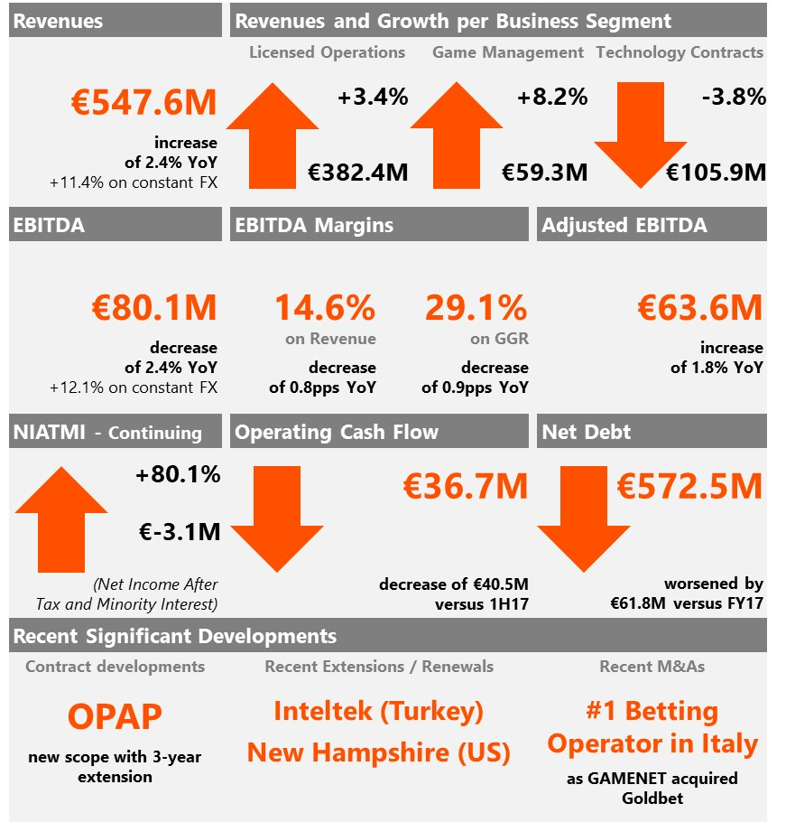

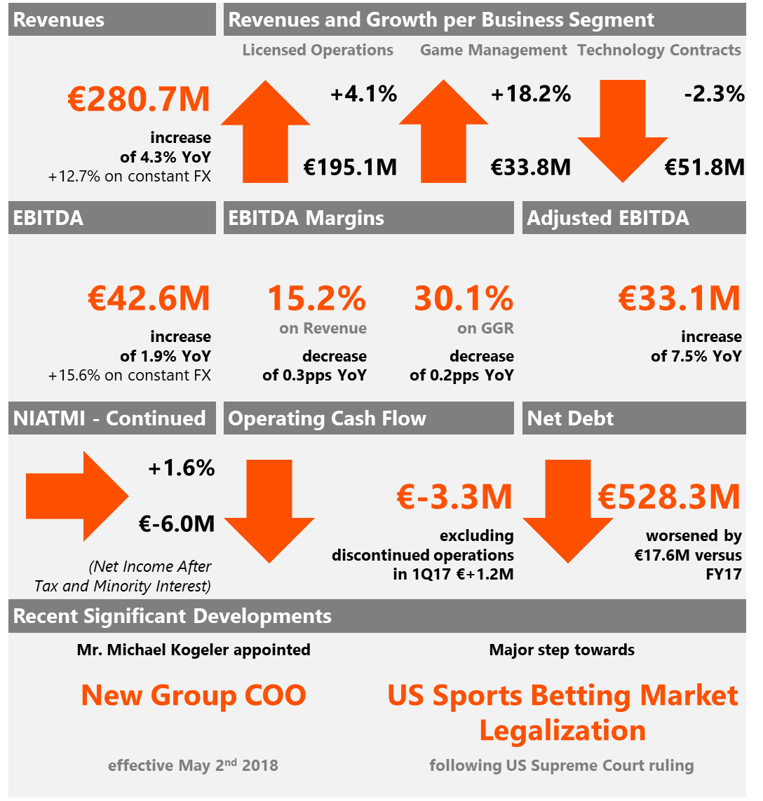
Group Headline Figures

(in € million) | 1H18 | 1H17 | %  Change | 2Q18 | 2Q17 | %  Change | LTM
Revenues (Turnover) | 547.6 | 534.7 | 2.4% | 267.0 | 265.7 | 0.5% | 1,117.1
GGR | 275.6 | 273.8 | 0.7% | 134.1 | 135.7 | -1.2% | 581.0
EBITDA | 80.1 | 82.1 | -2.4% | 37.5 | 40.3 | -6.9% | 169.5
EBITDA Margin (% on Revenue) | 14.6% | 15.4% | -0.8pps | 14.0% | 15.2% | -1.2pps | 15.2%
EBITDA Margin (% on GGR) | 29.1% | 30.0% | -0.9pps | 28.0% | 29.7% | -1.7pps | 29.2%
Adjusted EBITDA | 63.6 | 62.5 | 1.8% | 30.5 | 31.7 | -3.8% | 132.2
EBT | 32.5 | 17.5 | 85.7% | 19.2 | 3.6 | 433.3% | 25.3
EBT Margin (%) | 5.9% | 3.3% | +2.6pps | 7.2% | 1.4% | +5.8pps | 2.3%
NIATMI from continuing operations | -3.1 | -15.6 | 80.1% | 3.0 | -9.4 | - | -46.1
NIATMI from total operations | -3.1 | -25.8 | 88.0% | 3.0 | -20.3 | - | -30.7
Total Assets | 987.1 | 1,004.6 | - | - | - | - | -
Gross Debt | 767.4 | 664.0 | - | - | - | - | -
Net Debt | 572.5 | 516.8 | - | - | - | - | -
Operating Cash Flow | 36.7 | 77.2 | -52.5% | 0.8 | 38.0 | -97.9% | 113.5

INTRALOT Group CEO Antonios Kerastaris noted:
“In 1H2018 INTRALOT made great progress towards its strategic goals: first with the ongoing geographic refocus and the shift of the Revenue/Ebitda mix towards low-risk markets, evidenced by a stream of renewals and new clients in the US; and second with the deployment of our next generation solutions that start paying off our significant investment in new products for digital transformation reversing the significant cash impact of these key investments towards generating long term value.
Meanwhile we renewed our key contract for the operation of the popular sports betting game Iddaa in Turkey where we recorded a stellar revenue growth of 31% as well as 19% Ebitda growth in 1H2018 in local currency terms, and we saw a significant increase of the value of our Italian assets due to the acquisition of Goldbet by Gamenet that has now become the leading betting operator in the country with a combined market share of 17.7%.
Significant focus is now placed on the tremendous opportunities that open up in the nascent US sports betting market after the federal ban repeal in May and a lineup of tender awards that will be announced soon in mature markets.”

OVERVIEW OF RESULTS
WAGERS HANDLED
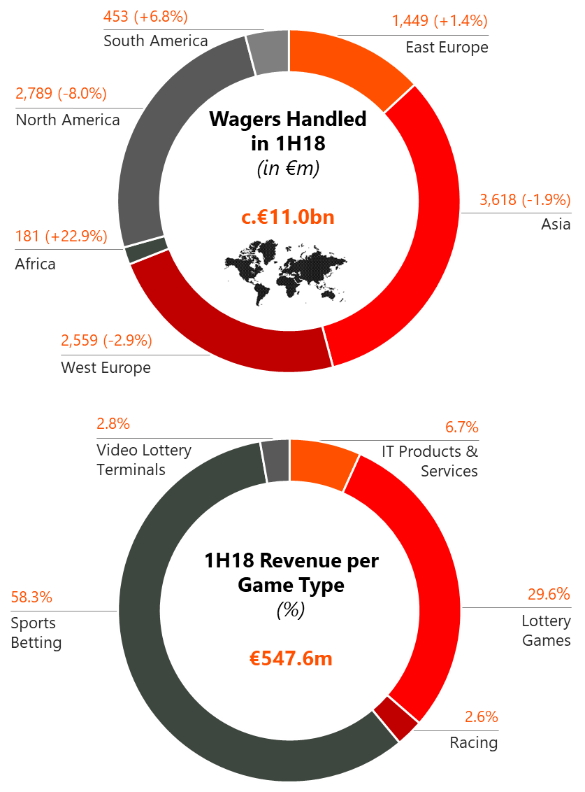
During the six-month period ended June 30th, 2018, INTRALOT systems handled €11.0b of worldwide wagers (from continuing operations), a 2.7% y-o-y decrease. Africa’s wagers increased by 22.9%, South America’s by 6.8%, and East Europe’s by 1.4%; while North America’s decreased by 8.0% (mainly FX driven), West Europe’s by 2.9%, and Asia’s by 1.9%.
REVENUE
- Reported consolidated revenues increased by 2.4% compared to 1H17, leading to total revenues for the six-month period ended June 30th, 2018, of €547.6m.
- Sports Betting was the largest contributor to our top line, comprising 58.3% of our revenues (posting a 9.5% revenue growth, year over year), followed by Lottery Games contributing 29.6% to Group turnover. Technology contracts accounted for 6.7% and VLTs represented 2.8% of Group turnover while Racing constituted the 2.6% of total revenues of 1H18.
- Reported consolidated revenues for the six-month period are up by €12.9m year over year. The main factors that drove top line performance per Business Activity are:
- €+12.6m (+3.4%) from our Licensed Operations (B2C) activity line with the increase attributed mainly to higher revenues in:
- Bulgaria (€+12.6m), mainly following the growth in Virtual Sports which is in part correlated with the increased payout.
- Poland with additional revenues of €9.9m due to the growth of the interactive Sport Betting channel (following market regulation) and the introduction of Virtual Games in 2Q17.
- Azerbaijan (€+5.4m), driven by the enhanced Sports Betting portfolio (both retail and online)
- in part offset by the impact of the suspended license in Cyprus in 4Q 2017 (€-8.4m)
- and the lower recorded revenues, in Euro terms, from our Argentinean licensed operations (€-4.7m). In local currency, 1H18 results posted a c.+30% year over year increase (higher compared to the 2015-2017 CAGR of c.27.0%), heavily affected though by the local currency fluctuations (c.53.0% devaluation against the Euro versus a year ago – in YTD average terms), with that being the key driver for the worsening performance in Euro terms in the six-month period
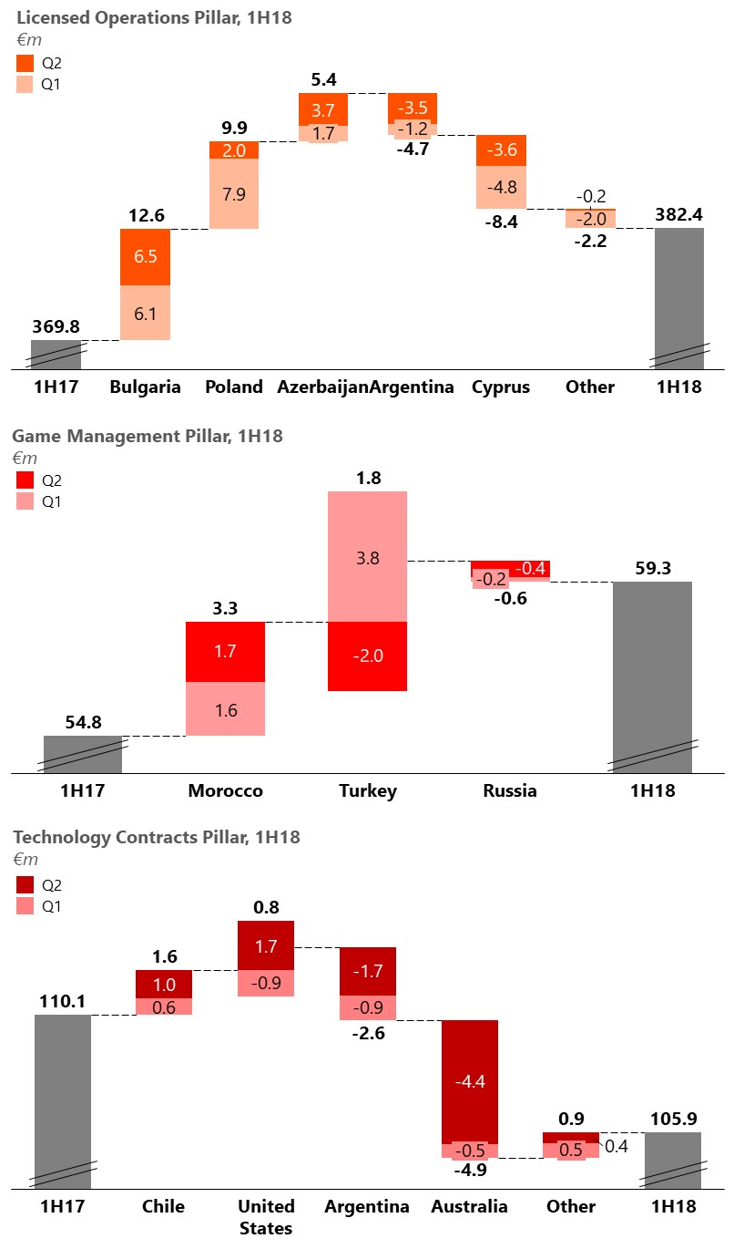
- €+4.5m (+8.2%) from our Management (B2B/ B2G) contracts activity line with the increase driven mainly by:
- Morocco’s (€+3.3m or c.+30% y-o-y growth) Sports Betting sales uplift attributed to the enhanced product offering
- and Turkey’s (€+1.8m) revenue increase attributed both to the growth of the Sport Betting Market year over year (c.+22% in local currency) and the shift towards Online Sports Betting (slightly over 60% market share vs. about 50% a year ago). The benefit of the Sports Betting market expansion and mix change has been partially offset by the devaluation of the local currency (c.26.0% devaluation against the Euro versus a year ago – in YTD average terms
- €-4.2m (-3.8%) from our Technology and Support Services (B2B/ B2G) activity line with the decrease attributed mainly to:
- Australia’s lower recorded revenue (€-4.9m) mainly as a result of a software license right sale in 2Q17 coupled with adverse local currency movement (c.9.2% devaluation against Euro – in YTD average terms)
- Argentina’s lower recorded sales in Euro terms (€-2.6m) as a result of the significantly adverse FX movement. In local currency, 1H18 results posted a c.+24.0% year over year increase (lower compared to the 2015-2017 CAGR of c.32.0%), heavily affected though by the local currency fluctuations (c.53.0% devaluation against the Euro versus a year ago – in YTD average terms),
- in part offset by the maturing Chilean contract (€+1.6m) that went live in early 1Q17, and by
- our US operations’ better performance (€+0.8m) in Euro terms. In local currency base our US operations recorded double digit growth compared to 1H17 (c.+14.0%) driven by the numerical segment stronger performance (high Jackpot levels), improved contract terms (e.g. Idaho) and higher equipment sales vs. a year ago (Massachusetts driven), in part offset though by the adverse USD movement (c.12.0% devaluation against the Euro versus a year ago – in YTD average terms).
- On a quarterly basis, revenues increased slightly at 0.5% compared to 2Q17, leading to total revenues for the three-month period started in April 1st, 2018, and ended in June 30th, 2018, of €267.0m. Increased revenues for the quarter (€+1.3m) are primarily attributed to increased sales in Bulgaria, Azerbaijan, Poland, the US, Morocco and Chile, in part offset by Argentina’s and Turkey’s FX impacted revenues, Australia revenue shortfall (software license right sale in 2Q17), and Cyprus suspended SB license
- Constant currency basis: In 1H18, revenues—net of the negative FX impact of €48.1m—reached €595.7m (+11.4% y-o-y), while 2Q18 revenues—net of the negative FX impact of €25.8m reached €292.7m (+10.1% y-o-y).
GROSS GAMING REVENUE & Payout
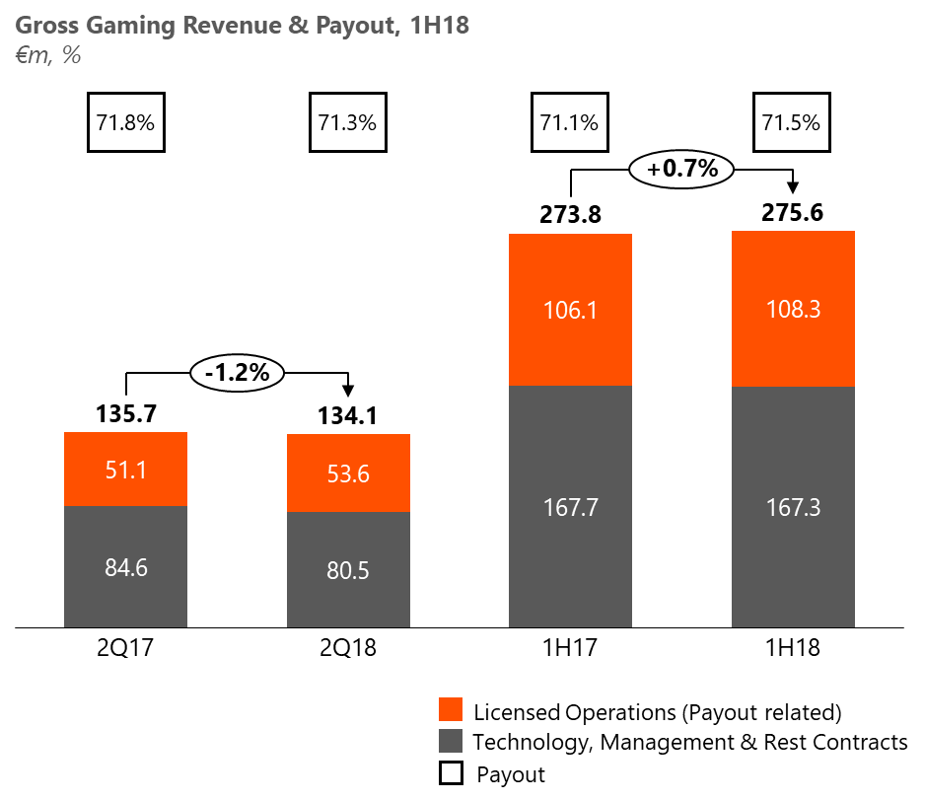
- Gross Gaming Revenue (GGR) from continuing operations increased by 0.7% (€+1.8m to €275.6m) year over year supported by:
- the increase in our payout related GGR (+2.1% y-o-y or €+2.2m), following the stronger top line growth of our licensed operations (+3.6% y-o-y on wagers), which came at an increased average Payout. YTD average Payout Ratio was up by 0.4pps vs. LY (71.5% vs. 71.1%) primarily due to an increasing payout trend in Bulgaria as well as its increasing wagers contribution and the increasing wagers contribution of Poland, in part offset by the suspended license in Cyprus in 4Q 2017.
- and a marginal decrease of the non-payout related GGR (€-0.4m y-o-y)
- In 2Q18, GGR from continuing operations decreased by -1.2% (or €-1.6m) year over year driven by:
- the decrease of the non-payout related GGR (-4.8% y-o-y or €-4.1m) largely due to the revenue shortfall in Australia (software license right sale in 2Q17)
- partially counterbalanced by the increase in our payout related GGR (+4.8% y-o-y or €+2.5m) following the better topline performance of our licensed operations (+2.9% y-o-y on wagers) supported further by a lower recorded average Payout Ratio. In 2Q18 the average Payout Ratio improved by -0.5pps vs. 2Q17 (71.3% vs. 71.8%).
EBITDA & EBITDA MARGINS
- EBITDA, from continuing operations, developed to €80.1m in 1H18, posting a decrease of -2.4% (€-2.0m) compared to the 1H17 results. On a macro level, organic growth fully absorbed LY’s software license right sale in Australia but could not fully absorb the extremely adverse FX movement across markets (e.g. Turkey, Argentina, the US and Australia).
- The main drivers for the decrease in 1H18 EBITDA, overturning the marginal 1H18 GGR increase, are:
- the deterioration in the OPEX margin (-2.3% over GGR) is mainly driven by the deterioration of the respective B2B/ B2G OPEX margin as a result of the increased administrative expenses (US mainly) and advertising expenses (largely driven by the increased marketing expenses in Turkey related to our Online Sport Betting activity), coupled with penalty provisions in Morocco (based on a performance reconciliation mechanism) and the first time consolidation of Bit8.
- the decrease in the Other operating income in 1H18, which totaled €7.3m compared to €8.8m in 1H17, mainly driven by less equipment lease income (following the recent contract renewals in OH and ID) coupled with the adverse USD movement against the Euro. The US other operating income shortfall, in local currency, has been more than recouped from the increased revenue in both contracts.
- partially offset by the improvement in the Taxes & Agent Fees margin (+1.0% over GGR) mainly due to the improvement of the Taxes & Agent Fees margin in each of the two categories. The B2C contracts Taxes & Agent Fees margin improvement is mainly driven by LATAM and the suspension of the Sport Betting license in Cyprus only partially diluted by the worsening contribution of Bulgaria and Poland, while that of the B2B/ B2G segment is driven by a more favorable sales mix in the retail Sports Betting segment in Turkey.
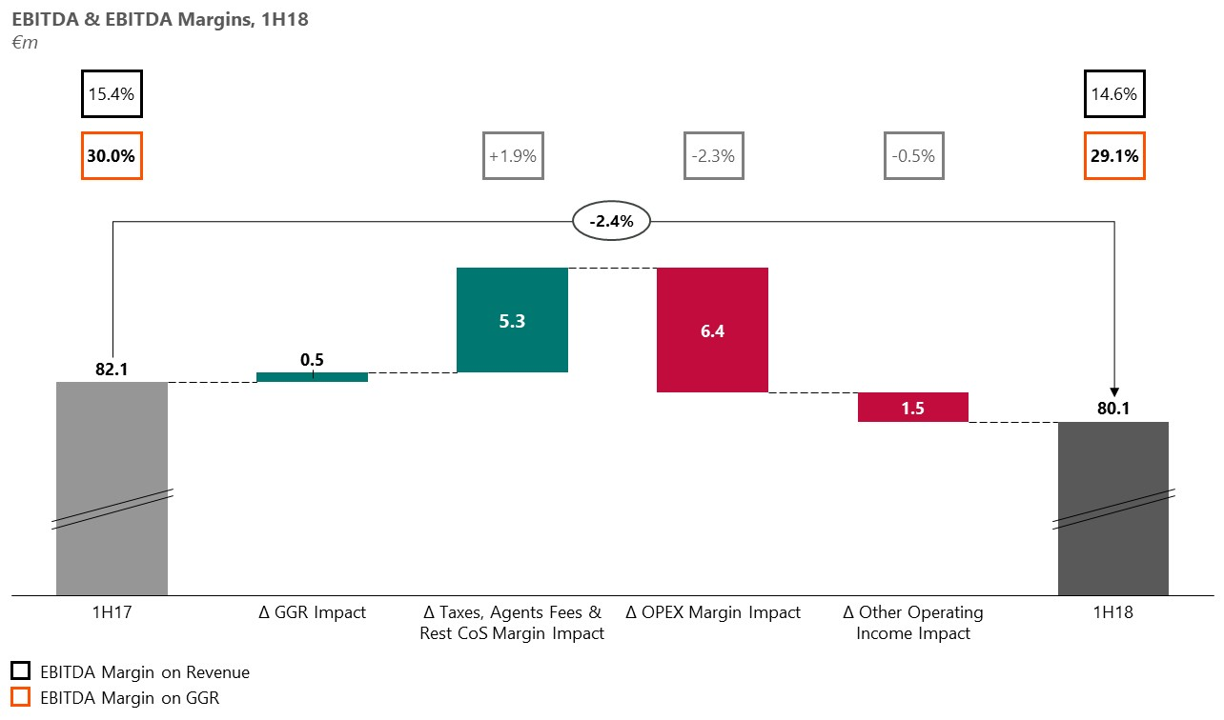
- and the improvement in the Rest of Cost of Sales margin (+0.9% over GGR) driven mainly by the improvement in the margin of the B2B/ B2G contracts following direct cost optimization across operations.

- On a yearly basis, EBITDA margin on sales, has been impacted by the worsening margins of the B2B/ B2G segment (mainly due to the software license right sale in Australia in 2Q17), decreasing to 14.6% compared to 15.4% in 1H17.
- On a quarterly basis, EBITDA deteriorated by -6.9% to €37.5m, mainly due to the absence of non-recurring revenue in Australia in 2Q17 and the adverse FX vs. a year ago
- On a quarterly basis, EBITDA margin on GGR, decreased to 28.0% compared to 29.7% in 2Q17, as a result of the B2B/ B2G segment margin contraction primarily due to the Australian license right sale a year ago.
- LTM EBITDA developed to €169.5m posting a slight decrease of -1.6% vs. 1Q18.
- Constant currency basis: In 1H18, EBITDA, net of the negative FX impact of €11.9m, reached €92.0m (+12.1% y-o-y) while 2Q18 EBITDA, net of the negative FX impact of €6.2m reached €43.7m (+8.4% y-o-y)

EBT / NIATMI
- EBT in 1H18 totaled €32.5m, significantly higher compared to €17.5m in 1H17. The impact of the decreased EBITDA described above (y-o-y: €-2.0m) was completely counterbalanced by the significantly better FX results (€+8.0m vs. 1H17) driven mainly by the better USD performance against the local currencies (e.g. high portion of Cash and Cash equivalents in Turkish Entities are held in USD) — being in part offset though by the deterioration of local currencies against EUR, the lower D&A for the period (favorable impact: €+3.0m vs. 1H17), the better results derived from the equity method consolidation of associates (€+2.0m vs. 1H17; benefited by the better performance of our equity investments in Peru and Italy and the full consolidation of Bit8 in 4Q17), the higher income from participations/investments (€+1.7m; assisted mainly by the higher dividend received from our investment in Hellenic Lotteries in 2Q18), the better Net Interest results (€+1.6m), and the lower impairments of assets for the period (€+0.7m).
- In 2Q18, the significantly better FX results (€+11.3m driven by the USD performance against the local currencies), coupled with the lower D&A (favorable impact: €+2.0m), the better results from equity method consolidation (€+1.6m), the better Net Interest results (€+1.5m), the higher income from participations/investments (€+1.2m), and the lower impairment of assets (€+0.7m) more than absorbed the recorded y-o-y EBITDA deficit (€-2.8m vs. 2Q17), thus, concluding to an EBT of €19.2m (+15.6m vs. 2Q17).
- Constant currency basis: In 1H18 EBΤ, adjusted for the FX impact, reached €39.4m from €21.8m in 1H17 while in 2Q18 adjusted for the FX impact, concluded to €18.6m from €8.6m in 2Q17.
- NIATMI from continuing operations in 1H18 concluded at €-3.1m compared to €-15.6m in 1H17. NIATMI from total operations in 1H17 was further deteriorated from the PAT contribution of the prior period’s discontinued operations (€-10.2m) and concluded at €-25.8m (in 1H18 there were no discontinued entities). In 2Q18, NIATMI from continuing operations was positive and reached €+3.0m (vs. €-9.4m y-o-y). NIATMI from total operations in 2Q17 was €-20.3m impacted by the PAT contribution of the prior period’s discontinued operations (€-10.9m)
- Constant currency basis: NIATMI (total operations) in 1H18, on a constant currency basis, reached €+0.3m from €-7.4m in 1H17 while in 2Q18 reached €1.1m from €-1.4m

CASH-FLOW
- Operating Cash-flow posted a considerable decrease in 1H18 at €36.7m vs. €77.2m in 1H17. Excluding the operating cash-flow contribution of our discontinued operations (Jamaica, Santa Lucia, Russia, and Slovakia) in 1H17 (€+9.1m), the cash-flow from operating activities is lower by €31.4m (€36.7m vs. €68.1m) mainly driven by the adverse working capital movement of 1H18 (€-30.5m vs. €-0.2m in 1H17). Current period WC impact is driven by the repayment of a long due interest-bearing liability (€-13.0m) and the inventory buildup for new projects (€-12.8m) largely as a result of the Illinois and Ohio projects.
- Adjusted Free Cash Flow in 1H18 increased by €2.2m, to €12.6m compared to €10.4m a year ago despite the lower recorded EBITDA (y-o-y). Key contributors to this variance were the dividend received from our equity investment in Italy & Greece (Gamenet first-time dividend distribution and the higher dividend vs. 1H17 from “Hellenic Lotteries S.A.”), the increased interest received for the cash held in the Turkish entities, in part only offset by the higher than prior period dividends paid to our partners in Azerbaijan, Turkey, and Argentina. In 2Q18, the Adjusted Free Cash Flow reached €18.5m, up by €18.3m vs. 1H17, significantly benefited by the timing variance of the bond coupons payment schedule (following the refinancing that took place in 3Q17 resulting in coupon payments across Q1 and Q3 vs. a coupon payment every Quarter previously), and the higher dividends received from our equity investments in Italy and Greece.
- Net Capex in 1H18 was €42.4m compared to €41.2m in 1H17 with the increased Capex in the US and the last installment towards the strategic partnership with AMELCO (both in 2Q18) being the key contributors to bring Net Capex to similar levels on a year-over-year basis (closing the positive gap of €10.4m in 1Q18 vs. 1Q17). Headline Capex items in 1H18 include €9.8m towards R&D, €16.3m in the US mainly towards the Illinois new contract, Ohio contract renewal, and New Hampshire’s “Keno” service launch, and €5.7m towards AMELCO. All other net additions amount to €10.6m for 1H18. Maintenance CAPEX for 1H18 stood at €11.7m, or 27.4% of the overall capital expenditure in 1H18 (€42.7m), at the same levels as a year ago (1H17; €11.9m – excluding discontinued operations in Jamaica, Santa Lucia, Slovakia & Russia).
- Net Debt, as of June 30th, 2018, stood at €572.5m, up €61.8m compared to December 31st 2017 as a result of our decision to invest in software (€-5.7m AMELCO), the investments in our US business (€-15.9m towards growth & renewal CAPEX in the US), the repayment of a long due interest bearing liability (€-13.0m), the inventory buildup for new projects (€-12.8m; as described above), own shares repurchase (€-5.5m), the net results from investments (€-3.6m; the outflow for an indirect stake in “Hellenic Casino Parnitha S.A.” of €6.8m being in part offset by the share capital return of €3.1m from the Hellenic Lotteries equity investment) and the bond IFRS treatment (€-2.2m). On a quarterly basis, Net Debt increased by €44.2m significantly affected by the liability payment and the inventory buildup, the AMELCO investment and the increased CAPEX outflow in the US.

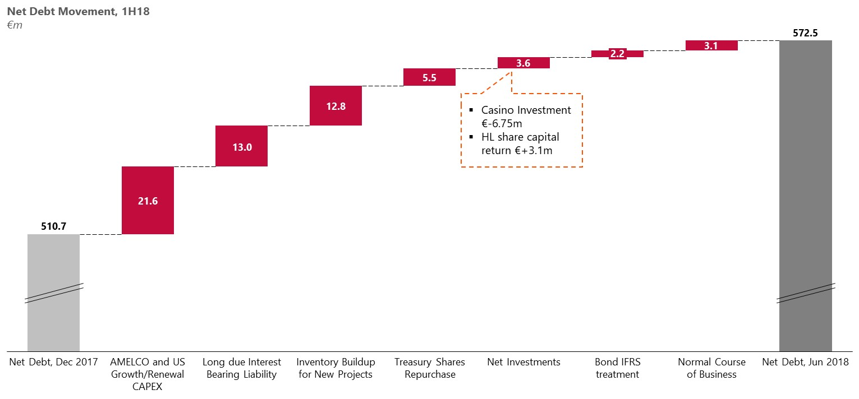
- As of June 30th, 2018, a repurchase of Notes amounting to €5.0 million (€500M, 5.25% Senior Notes due 2024 ISIN XS1685702794) has occurred. We may proceed to repurchases of our debt again in the future subject to market conditions.

RECENT/ SIGNIFICANT COMPANY DEVELOPMENTS
- On July 2nd, 2018, INTRALOT announced a five-year extension to its current gaming systems contract with the New Hampshire Lottery Commission. The extension will commence at the end of the current contract term of June 30, 2020, furthering the contract through June 30, 2025. The New Hampshire Lottery Commission is the first and oldest U.S. state lottery and continues to be an industry leader. INTRALOT began its partnership with the New Hampshire lottery in 2010.
- On July 5th, 2018, INTRALOT announced the renewal of its “WLA Certification of Alignment” with the Responsible Gaming Framework through July 2021. Granted accreditation is in accordance with the criteria set in WLA Responsible Gaming Certification Standards for Associate Members and covers all corporate functions certifying the integrity of the games and corporate conduct.
- On July 24th, 2018, GAMENET Group – in which INTRALOT holds a 20% equity investment – signed an agreement for the acquisition of 100% of Goldbet. Following the transaction, GAMENET Group became the leading betting operator in Italy with the country's largest network of sports betting (over 1,700 points of sale). The acquisition will significantly increase the degree of diversification of the Group’s product portfolio and its profitability.
- During the period between 01.01.2018 and 30.06.18, Intralot SA has proceeded with the repurchase of 5,444,410 own shares amounting to €5.5 million with an average price of €1.01, while for the period between 01.07.2018 and 29.08.18, Intralot SA has proceeded with the repurchase of 2,669,882 own shares amounting to €2.3 million with an average price of €0.86.
- On August 28th, 2018, INTRALOT announced the signing of a new contract between the Turkish State Organization SporToto and INTELTEK, its subsidiary in Turkey, in partnership with Turkcell, to continue the operation and technical support of the successful and extremely popular fixed odds sports betting game Iddaa for up to one additional year, starting August 29, 2018. The new contract is under the same main terms with the 10-year contract that expires on August 28, 2018.

APPENDIX
Performance per Business Segment
YTD Performance
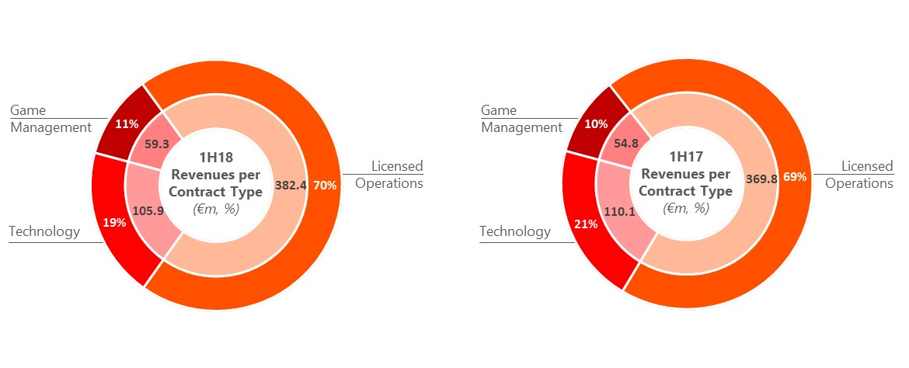
Quarterly Performance
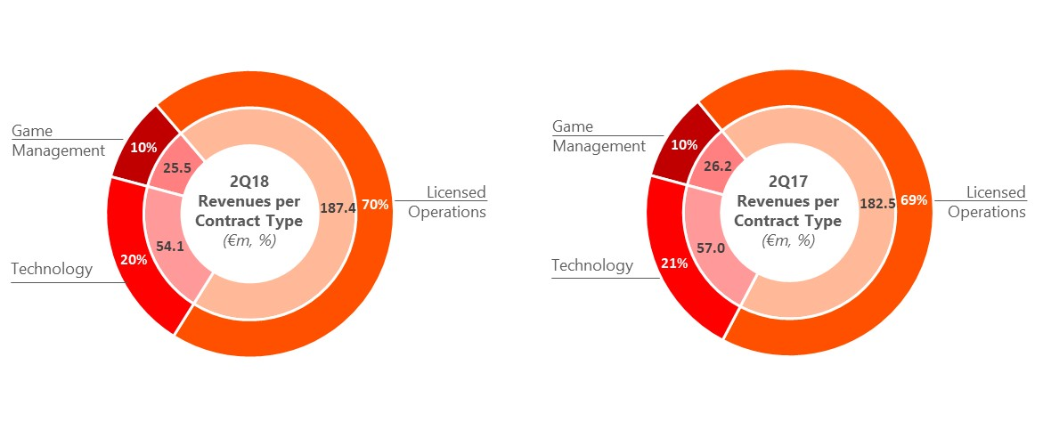
Performance per Geography
Revenue Breakdown
(in € million) | 1H18 | 1H17 | %  Change
Europe | 320.6 | 305.3 | 5.0%
Americas | 100.6 | 108.9 | -7.6%
Other | 151.1 | 145.7 | 3.7%
Eliminations | -24.7 | -25.2 | -
Total Consolidated Sales | 547.6 | 534.7 | 2.4%
Gross Profit Breakdown
(in € million) | 1H18 | 1H17 | %  Change
Europe | 38.6 | 31.2 | 23.7%
Americas | 14.2 | 13.1 | 8.4%
Other | 66.4 | 63.7 | 4.2%
Eliminations | -2.7 | 0.4 | -
Total Consolidated Gross Profit | 116.5 | 108.4 | 7.5%

Gross Margin Breakdown
 | 1H18 | 1H17 | %  Change
Europe | 12.0% | 10.2% | +1.8pps
Americas | 14.1% | 12.0% | +2.1pps
Other | 43.9% | 43.7% | +0.2pps
Total Consolidated Gross Margin | 21.3% | 20.3% | +1.0pps

INTRALOT Parent Company results
- Revenues for the period increased by 8.9% to €29.4m. The sales boost is primarily driven by the increased royalties/ software license fees from subsidiaries and by the higher hardware sales to subsidiaries and associates (e.g. Peru).
- EBITDA increased to €3.0m from €1.4m in 1H17. The EBITDA variance is mainly the result of the positive Gross Profit variance y-o-y driven by the higher Revenues described above supported also by improved OPEX savings.
- Earnings after Taxes (EAT) at €-1.4m from €0.0m in 1H17.
- LTM EBITDA figure is higher by €2.4m vs. LTM 1Q18 reflecting the significantly better top line performance of the Company in 2Q18 (vs. 2Q17).

(in € million) | 1H18 | 1H17 | %  Change | LTM
Revenues | 29.4 | 27.0 | 8.9% | 69.2
Gross Profit | 11.0 | 9.9 | 11.1% | 29.2
Other Operating Income | 0.1 | 0.1 | 0.0% | 2.0
OPEX | -15.0 | -16.4 | -8.5% | -33.3
EBITDA | 3.0 | 1.4 | 114.3% | 10.4
EAT | -1.4 | 0.0 | - | -12.9
CAPEX (paid) | -8.8 | -8.5 | 3.5% | -15.8

CONFERENCE CALL INVITATION – 1H18 FINANCIAL RESULTS
Antonios Kerastaris, Group CEO, Georgios Koliastasis, Group CFO, Nikolaos Pavlakis, Group Tax & Accounting Director, Andreas Chrysos, Group Budgeting, Controlling & Finance Director and Michail Tsagalakis, Capital Markets Director, will address INTRALOT’s analysts and institutional investors to present the Company’s First Half 2018 results, as well as to discuss the latest developments at the Company.
The financial results will be released on the ATHEX website (www.helex.gr), and will be posted on the company’s website (www.intralot.com) on Thursday 30th August, 2018 (after the closing of the trading session of the ATHEX).

AGENDA: Brief Presentation - Question and Answer Session
CONFERENCE CALL DETAILS
Date: 31st August 2018
Time: Greek time 17:00 - UK time 15:00 - CET 16:00 - USA time 10:00 (East Coast Line)
Conference Phone GR | 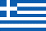 + 30 211 180 2000
Conference Phone GR | + 30 210 94 60 800
Conference Phone GB | + 44 (0) 203 059 5872
Conference Phone GB | + 44 (0) 800 368 1063
Conference Phone US | + 1 516 447 5632
We recommend that you call any of the above numbers 5 to 10 minutes before
the conference call is scheduled to start.

LIVE WEBCAST DETAILS
The conference call will be available via webcast in real time over the Internet and you may join by linking at the internet site:
https://services.choruscall.eu/links/intralot18H1.html
DIGITAL PLAYBACK

There will be a digital playback on the 31st August 2018 at 19:00 (GR Time).
This Service will be available until the end of the business day 11th September 2018.

Please dial the following numbers and the PIN CODE: 059 # from a touch-tone telephone

Digital Playback UK: + 44 (0) 203 059 5874
Digital Playback US: + 1 631 257 0626
Digital Playback GR: + 30 210 94 60 929
In case you need further information, please contact Intralot, Mr. Michail Tsagalakis, at the telephone number: +30 213 0397000 or Chorus Call Hellas S.A., our Teleconferencing Services Provider, Tel. +30 210 9427300.
SUMMARY OF FINANCIAL STATEMENTS
Group Statement of Comprehensive Income
(in € million) | 1H18 | 1H17 | % Change | 2Q18 | 2Q17 | % Change | LTM
Revenues | 547.6 | 534.7 | 2.4% | 267.0 | 265.7 | 0.5% | 1,117.1
Gross Profit | 116.5 | 108.4 | 7.5% | 55.7 | 53.7 | 3.7% | 250.0
Other Operating Income | 7.3 | 8.8 | -17.0% | 3.8 | 4.6 | -17.4% | 15.7
OPEX | -75.5 | -69.9 | 8.0% | -38.1 | -36.1 | 5.5% | -156.1
EBITDA | 80.1 | 82.1 | -2.4% | 37.5 | 40.3 | -6.9% | 169.5
Margin | 14.6% | 15.4% | -0.8pps | 14.0% | 15.2% | -1.2pps | 15.2%
EBIT | 48.3 | 47.3 | 2.1% | 21.4 | 22.2 | -3.6% | 109.6
Interest expense (net) | -22.0 | -23.6 | -6.8% | -10.9 | -12.3 | -11.4% | -61.3
Exchange differences | 3.7 | -4.3 | - | 6.3 | -5.0 | - | 2.0
Other | 2.5 | -1.9 | - | 2.4 | -1.3 | - | -25.0
EBT | 32.5 | 17.5 | 85.7% | 19.2 | 3.6 | 433.3% | 25.3
NIATMI | -3.1 | -25.8 | 88.0% | 3.0 | -20.3 | - | -30.7
NIATMI continuing | -3.1 | -15.6 | 80.1% | 3.0 | -9.4 | - | -46.2
NIATMI discontinued | 0.0 | -10.2 | - | 0.0 | -10.9 | - | 15.5
Group Statement of Financial Position
(in € million) | 1H18 | FY17
Tangible Assets | 105.8 | 102.8
Intangible Assets | 328.2 | 324.5
Other Non-Current Assets | 179.1 | 178.6
Inventories | 45.1 | 31.5
Trade receivables | 74.2 | 84.2
Other Current Assets | 254.7 | 300.3
Total Assets | 987.1 | 1,021.9
Share Capital | 47.1 | 47.7
Other Equity Elements | -7.4 | 10.1
Non-Controlling Interests | 21.8 | 32.0
Total Shareholders’ Equity | 61.5 | 89.8
Long-term Debt | 742.7 | 729.4
Provisions/ Other Long term Liabilities | 32.3 | 29.6
Short-term Debt | 24.7 | 19.3
Other Short-term Liabilities | 125.9 | 153.8
Total Liabilities | 925.6 | 932.1
Total Equity and Liabilities | 987.1 | 1,021.9

Group Statement of Cash Flows
(in € million) | 1H18 | 1H17
EBT from continuing operations | 32.5 | 17.5
EBT from discontinued operations | 0.0 | -3.0
Plus/less Adjustments | 48.6 | 78.6
Decrease/(increase) of Inventories | -11.5 | -4.1
Decrease/(increase) of Receivable Accounts | -0.9 | 0.2
(Decrease)/increase of Payable Accounts | -18.1 | 3.7
Income Tax Paid | -13.9 | -15.7
Net Cash from Operating Activities | 36.7 | 77.2
Net CAPEX | -42.4 | -41.2
(Purchases) / Sales of subsidiaries & other investments | -3.6 | 4.5
Interest received | 4.1 | 2.6
Dividends received | 6.8 | 1.8
Net Cash from Investing Activities | -35.1 | -32.3
Repurchase of own shares | -5.5 | 0.0
Cash inflows from loans | 52.7 | 52.5
Repayment of loans | -28.8 | -53.2
Bond buybacks | -5.0 | 0.0
Repayment of Leasing Obligations | -2.9 | -0.9
Interest and similar charges paid | -25.1 | -25.4
Dividends paid | -27.8 | -27.5
Net Cash from Financing Activities | -42.4 | -54.5
Net increase / (decrease) in cash for the period | -40.8 | -9.6
Exchange differences | -2.3 | -7.6
Cash at the beginning of the period | 238.0 | 164.4
Cash at the end of the period from total operations | 194.9 | 147.2

About INTRALOT

INTRALOT, a public listed company established in 1992, is a leading gaming solutions supplier and operator active in 50 regulated jurisdictions around the globe. With €1.1 billion turnover and a global workforce of approximately 5,100 employees (3,100 of which in subsidiaries and 2,000 in associates) in 2017, INTRALOT is an innovation – driven corporation focusing its product development on the customer experience. The company is uniquely positioned to offer to lottery and gaming organizations across geographies market-tested solutions and retail operational expertise. Through the use of a dynamic and omni-channel approach, INTRALOT offers an integrated portfolio of best-in-class gaming systems and product solutions & services addressing all gaming verticals (Lottery, Betting, Interactive, VLT). Players can enjoy a seamless and personalized experience through exciting games and premium content across multiple delivery channels, both retail and interactive. INTRALOT has been awarded with the prestigious WLA Responsible Gaming Framework Certification by the World Lottery Association (WLA) for its global lottery operations.

For more info:
-Mr. Chris Sfatos, Group Director Corporate Affairs, email: sfatos@intralot.com or
-Investor Relations Dept. email: ir@intralot.com
Phone: +30-210 6156000, Fax: +30-210 6106800, www.intralot.com

Calculated as Proportionate EBITDA of fully consolidated entities including EBITDA from equity investments in Italy, Peru, Greece, and Taiwan
Licensed Operations Revenue include also a small portion of non-Payout related revenue, i.e. value-added services, which totaled €2.1 million and €2.8 million for 1H18 and 1H17, and €0.9 million and €13 million for 2Q18 and 2Q17 respectively
Analysis in the EBITDA section excludes Depreciation & Amortization
Calculated as EBITDA – Maintenance CAPEX – Cash Taxes – Net Cash Finance Charges (excluding refinancing charges) – Net Dividends Paid; all finance metrics exclude the impact of discontinued operations

