INTRALOT Group
ANNOUNCEMENT
OF FINANCIAL RESULTS

for the three month period
ended March 31st, 2018

PRESS RELEASE

“INTRALOT announces y-o-y Revenue (+4.3%)
and EBITDA (+1.9%) growth for 1Q18”

May 31st, 2018

INTRALOT SA (RIC: INLr.AT, Bloomberg: INLOT GA), an international gaming solutions and operations leader, announces its financial results for the three month period ended March 31st, 2018, prepared in accordance with IFRS.

OVERVIEW
- Revenue and EBITDA growth of +12.7% and +15.6% year over year respectively on a constant currency basis.
- Group Revenues increased by 4.3% in 1Q18, compared to 1Q17.
- EBITDA in the three-month period grew by 1.9% year over year.
- EBITDA margins on sales and on GGR both contracted by 0.3pps (at 15.2%) and 0.2pps (at 30.1%), respectively.
- EBT margin developed to 4.7% (-0.5pps vs. 1Q17).
- NIATMI (Net Income After Tax and Minority Interest) from continuing operations remained relatively stable vs. last year, developing to €-6.0m from €-6.1m.
- Operating Cash Flow in 1Q18 below last year by -8.4% or €-3.3m
- Net Debt stood at €528.3m, up €17.6m compared to December 31st 2017.
- In early May 2018, the US Supreme Court has ruled that PASPA (the Professional and Amateur Sports Protection Act), a 1992 federal law which prohibited states from legalizing sports betting, is unconstitutional.
- In May 2018, Intralot welcomed Mr. Michael Kogeler, as its new Group Chief Operating Officer.
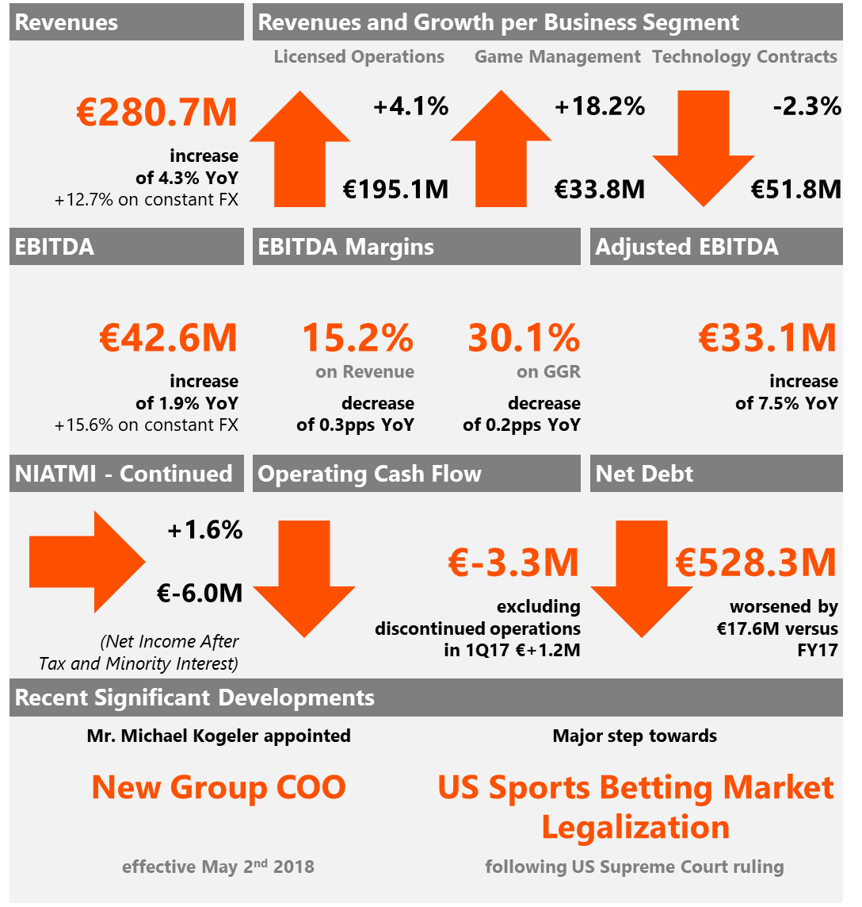
1Q18 INFOGRAPHIC

Group Headline Figures

(in € million) | 1Q18 | 1Q17 | %  Change | LTM
Revenues (Turnover) | 280.7 | 269.0 | 4.3% | 1,115.9
GGR | 141.5 | 138.1 | 2.5% | 582.6
EBITDA | 42.6 | 41.8 | 1.9% | 172.3
EBITDA Margin (% on Revenue) | 15.2% | 15.5% | -0.3pps | 15.4%
EBITDA Margin (% on GGR) | 30.1% | 30.3% | -0.2pps | 29.6%
Adjusted EBITDA | 33.1 | 30.8 | 7.5% | 133.4
EBT | 13.2 | 13.9 | -5.0% | 9.6
EBT Margin (%) | 4.7% | 5.2% | -0.5pps | 0.9%
NIATMI from continuing operations | -6.0 | -6.1 | 1.6% | -58.5
NIATMI from total operations | -6.0 | -5.4 | -11.1% | -54.0
Total Assets | 997.8 | 1,056.4 | - | 997.8
Gross Debt | 751.6 | 669.5 | - | 751.6
Net Debt | 528.3 | 508.9 | - | 528.3
Operating Cash Flow | 35.9 | 39.2 | -8.4% | 150.7

INTRALOT Group CEO Antonios Kerastaris noted:
“The 2018 Q1 results show stronger sales and continuing growth in developed markets, reflecting increasingly successful market development efforts along with an upgrade of our offering with next generation products and services for Lotteries digital transformation. Emphasis remains on growth in markets such as the United States where the recent lift of the federal ban on sports betting creates tremendous business opportunities from the rise of a potential USD 20bn market in annual GGR terms, on top of great prospects in new flagship projects such as the Illinois State Lottery.”

OVERVIEW OF RESULTS
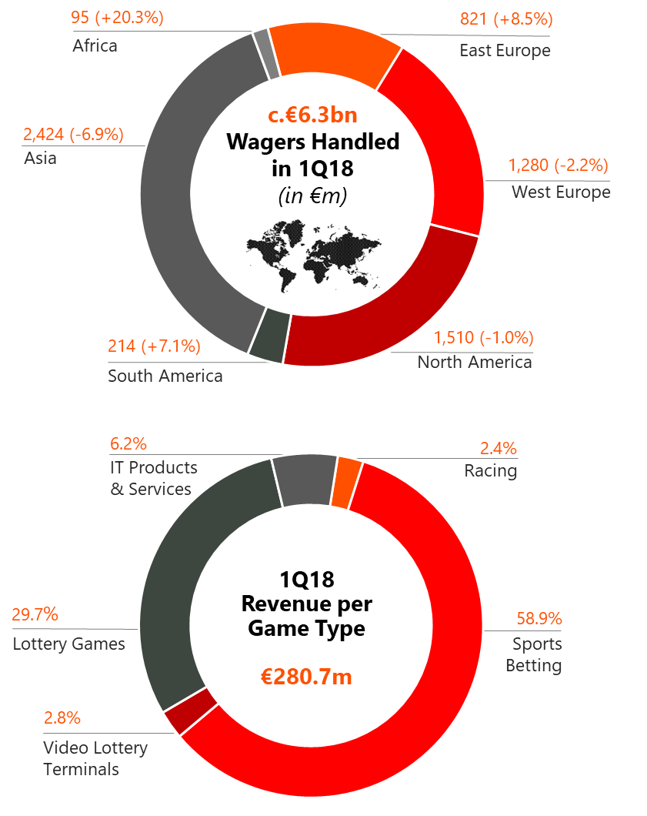
WAGERS HANDLED
During the three-month period ended March 31st, 2018, INTRALOT systems handled €6.3b of worldwide wagers (from continuing operations), a 2.0% y-o-y decrease. Africa’s wagers increased by 20.3%, East Europe’s by 8.5%, and South America’s by 7.1%; while Asia’s decreased by 6.9%, West Europe’s by 2.2%, and North America’s by 1.0%.
REVENUE
- Reported consolidated revenues increased by 4.3% compared to 1Q17, leading to total revenues for the three-month period ended March 31st, 2018, of €280.7m.
- Sports Betting was the largest contributor to our top line, comprising 58.9% of our revenues (posting double digit revenue growth, +11.9% year over year), followed by Lottery Games contributing 29.7% to Group turnover. Technology contracts accounted for 6.2% and VLTs represented 2.8% of Group turnover while Racing constituted the 2.4% of total revenues of 1Q18.
- Reported consolidated revenues for the three-month period are up by €11.7m year over year. The main factors that drove top line performance per Business Activity are:
- €+7.7m (+4.1%) from our Licensed Operations (B2C) activity line with the increase attributed mainly to higher revenues in:
- Poland with additional revenues of €7.9m due to the growth of the interactive Sport Betting channel (following market regulation) and the introduction of Virtual Games in 2Q17.
- Bulgaria (€+6.1m), mainly due to the growth in Virtual Sports fueled in part by the increased payout.
- Azerbaijan (€+1.7m), driven by the Sports Betting revenue growth (both retail and online)
- in part offset by the impact of the suspended license in Cyprus in 4Q 2017 (€-4.8m)
- and the lower recorded revenues, in Euro terms, from our Argentinean licensed operations (€-1.2m). In local currency, 1Q18 results posted a c.+34.0% year over year increase (higher compared to the 2015-2017 CAGR of c.27.0% in part also due to higher payout in 1Q18 vs. FY2017 and FY2016), heavily affected though by the local currency fluctuations (c.45.0% devaluation against the Euro versus a year ago) which is also the main driver for the worsening performance in Euro terms in the three-month period
- €+5.2m (+18.2%) from our Management (B2B/ B2G) contracts activity line with the increase driven mainly by:
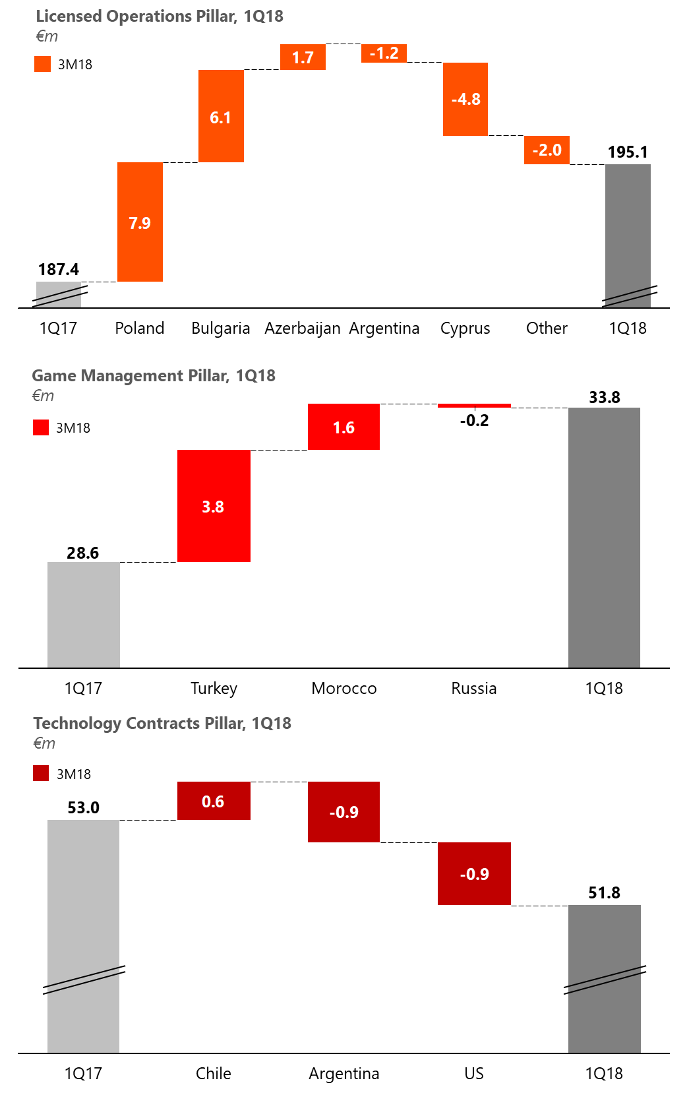
- Turkey’s (€+3.8m) revenue increase attributed both to the growth of the Sport Betting Market year over year (c.+26% in local currency) as well as due to the shift towards Online Sports Betting (close to 60% market share vs. slightly below 50% a year ago). The benefit of the Sports Betting market expansion and mix change has been partially offset by the devaluation of the local currency (c.19.0% devaluation against the Euro versus a year ago)
- Morocco’s (€+1.6m) Sports Betting sales uplift attributed to the enhanced product offering
- €-1.2m (-2.3%) from our Technology and Support Services (B2B/ B2G) activity line with the decrease attributed mainly to:
- US operations worse performance (€-0.9m) in Euro terms. In local currency base our US operations recorded double digit growth compared to 1Q17 (c.+11.0%) driven by the numerical segment stronger performance, which has been fully offset though by the adverse USD movement (c.15.0% devaluation against the Euro versus a year ago). The double digit growth has also been supported by the Idaho contract renewal on better terms.
- Argentina’s lower recorded sales in Euro terms (€-0.9m) as a result of the significantly adverse FX movement. In local currency, 1Q18 results posted a c.+26.0% year over year increase (lower compared to the 2015-2017 CAGR of c.32.0%), heavily affected though by the local currency fluctuations (c.45.0% devaluation against the Euro versus a year ago)
- partially offset by the maturing Chilean contract (€+0.6m) that went live in early 1Q17
- Constant currency basis: In 1Q18, revenues—net of the negative FX impact of €22.4m—reached €303.0m (+12.7% y-o-y).
GROSS GAMING REVENUE & Payout
- Gross Gaming Revenue (GGR) from continuing operations increased by 2.5% (€+3.4m to €141.5m) year over year driven by:
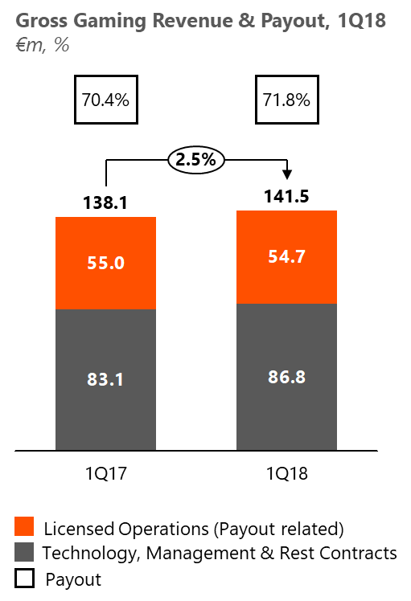
- The increase of the non-payout related GGR (+4.5% y-o-y or €3.7m) mainly due to the increase in our Management Contracts activity line revenue (+18.2% y-o-y or €+5.2m), partially offset by the softer top line performance of our Technology and Support Services activities (-2.3% y-o-y or €-1.2m)
- and the marginal decrease in our payout related GGR (-0.5% y-o-y or €-0.3m), which despite showcasing top line growth (+4.3% y-o-y on wagers), this came at an increased average Payout resulting overall in a slight decrease in GGR from payout related revenue. In 1Q18 the average Payout Ratio was up by 1.4pps vs. 1Q17 (71.8% vs. 70.4%) primarily due to increasing revenue contribution of countries with above average Payout (e.g. Bulgaria & Poland) as well as due to an increasing payout trend across most operations vs. LY. The Payout Ratio in 1Q18 has benefited from the suspended license in Cyprus in 4Q 2017.

EBITDA & EBITDA MARGINS
- EBITDA, from continuing operations, developed to €42.6m in 1Q18, posting an increase of 1.9% (€+0.8m) compared to the 1Q17 results.
- The main 1Q18 EBITDA growth drivers, besides the improved 1Q18 GGR, is:
- the improvement in the Taxes & Agent Fees margin (+1.3% over GGR) as a result of the product mix change (B2B/ B2G contracts increasing contribution vs. B2C contracts) as well as the improvement of the Taxes & Agent Fees margin in each of the two categories. The B2C contracts Taxes & Agent Fees margin improvement is mainly driven by the suspension of the license in Cyprus, while that of the B2B/ B2G segment is driven by a more favorable sales mix in the retail Sports Betting segment in Turkey
- the improvement in the Rest of Cost of Sales margin (+1.1% over GGR) driven mainly by the improvement in the margin of the B2B/ B2G contracts following direct cost optimization in our US operations
- partially offset by the decrease in the OPEX margin mainly driven by the deterioration of the respective B2B/ B2G OPEX margin as a result of the increasing marketing expenses in Turkey related to our Online Sport Betting activity
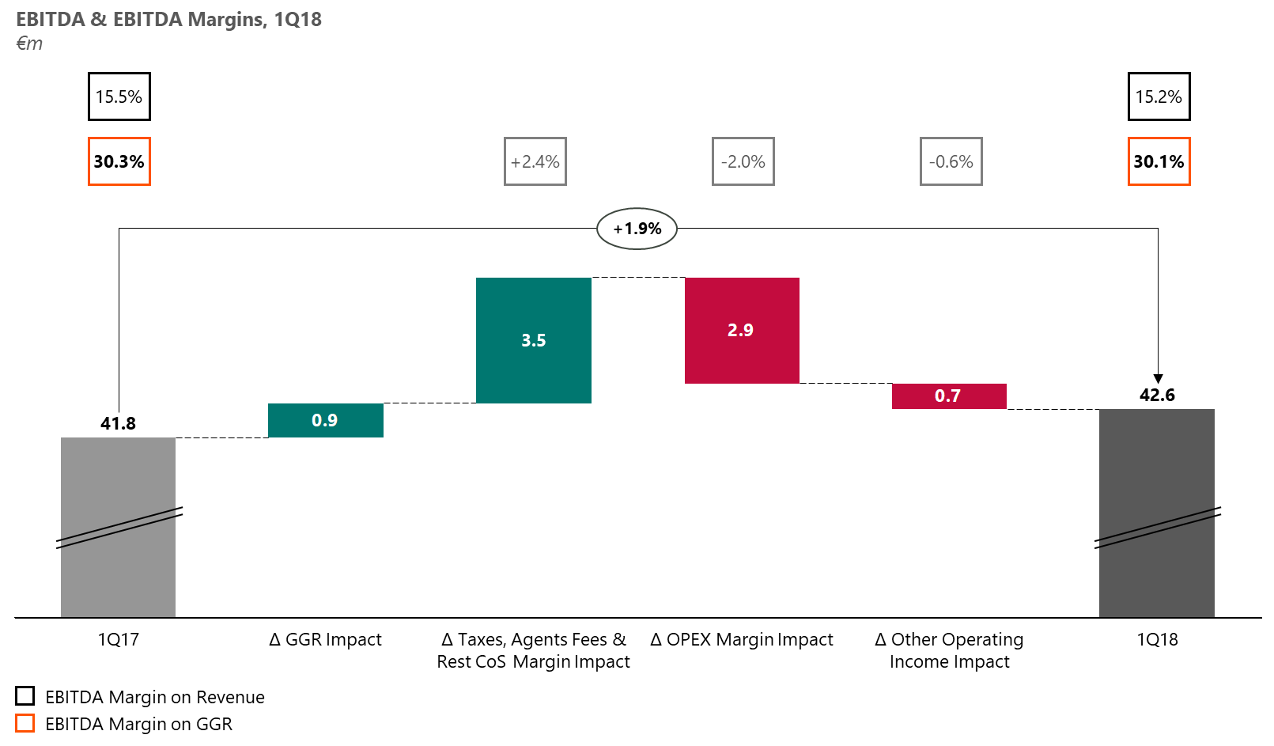
- the decrease in the Other operating income in 1Q18, which totaled €3.5m compared to €4.2m in 1Q17, mainly driven by less equipment lease income in Ohio and Idaho (following the recent contract renewals) coupled with the adverse USD movement against the Euro. The other operating income shortfall, in local currency, has been more than recouped from the increased revenue in both contracts.

- On a yearly basis, EBITDA margin on sales, has been impacted negatively by worsening margins (on sales) across both contract segments, i.e. B2B/ B2G and B2C, decreasing to 15.2% compared to 15.5% in 1Q17.
- LTM EBITDA developed to €172.3m posting a slight increase vs. FY17.
- Constant currency basis: In 1Q18, EBITDA, net of the negative FX impact of €5.8m, reached €48.4m (+15.6% y-o-y).

EBT / NIATMI
- EBT in 1Q18 totaled €13.2m compared to €13.9m in 1Q17. The positive EBITDA change y-o-y described above (€+0.8m) coupled with the lower D&A for the period (favorable impact: €+1.0m vs. 1Q17), the higher income from participations/investments (€+0.5m), and the better results derived from the equity method consolidation of associates (€+0.4m vs. 1Q17) was fully counterbalanced by the significantly worse FX effect of outstanding balances transaction (impact: €-3.5m vs. 1Q17).
- Constant currency basis: In 1Q18 EBΤ, adjusted for the FX impact, reached €20.8m from €13.1m in 1Q17.
- NIATMI from continuing operations in 1Q18 concluded at €-6.0m compared to €-6.1m in 1Q17, while NIATMI from total operations in 1Q17 was further benefited by the PAT contribution of the prior period’s discontinued operations (€+0.7m) and concluded at €-5.4m, while in 1Q18 there were no discontinued entities.
- Constant currency basis: NIATMI (total operations) in 1Q18, on a constant currency basis, reached €-0.9m from €-6.0m in 1Q17.
CASH-FLOW
- Operating Cash-flow posted a decrease in 1Q18 at €35.9m vs. €39.2m in 1Q17. Excluding the operating cash-flow contribution of our discontinued operations (Jamaica, Russia, and Slovakia) in 1Q17 (€+4.5m), the cash-flow from operating activities improved by €1.2m (€35.9m vs. €34.7) driven by the better EBITDA performance and the less taxes.
- Adjusted Free Cash Flow in 1Q18 developed to €-5.9m compared to €10.2m a year ago. The decrease is mainly the result of the timing variance of the bond coupons payment schedule (following the refinancing that took place in 3Q17 resulting in coupon payments across Q1 and Q3 vs. a coupon payment every Quarter previously), the front-loaded dividend payments to Inteltek’s shareholders in 1Q18 (compared to last year), and the higher dividends distributed to Bilyoner’s shareholders vs. a year ago.
- Net Capex in 1Q18 was €14.2m compared to €24.6m in 1Q17 significantly lower given the €11.7m spent in the prior period towards the strategic partnership with AMELCO. Headline Capex items in 1Q18 include €5.1m towards R&D, €4.1m in the US mainly towards the Illinois new contract, Ohio contract renewal, and New Hampshire’s “Keno” service launch. All other net additions amount to €5.0m for 1Q18. Maintenance CAPEX for 1Q18 stood at €5.9m, or 40.0% of the overall capital expenditure in 1Q18 (€14.8m), compared to €4.7m in 1Q17 (excluding discontinued operations in Jamaica, Slovakia & Russia).
- Cash and cash equivalents at the end of the 1Q18 period decreased by €14.7m vs. December 31st 2017; Main contributors to this movement are the €-6.8m investment towards an indirect stake in “Hellenic Casino Parnitha S.A.” (7.65%), the dividend distribution to minorities (€-15.5m), the bond coupons payment of €-21.2m, which were partially offset by a loan uptake of €+15.0m, and the cash generated in the normal course of business.
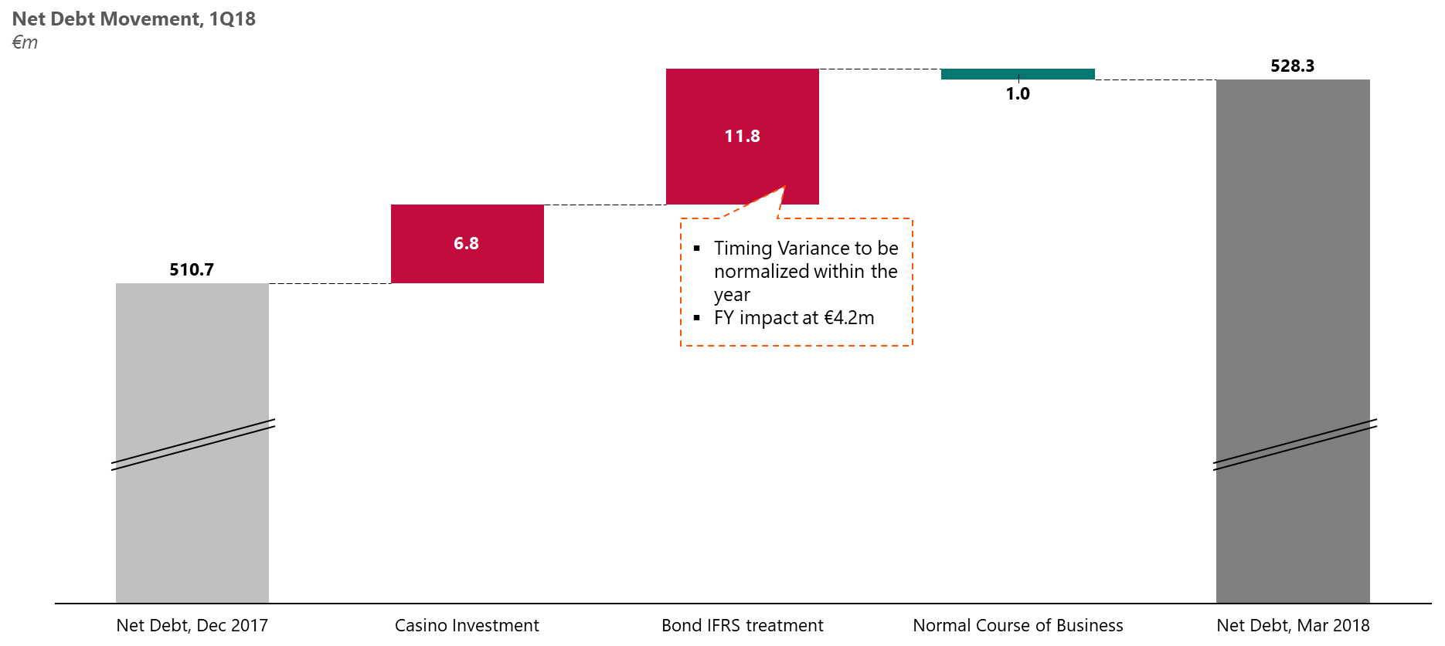
- Net Debt, as of March 31st, 2018, stood at €528.3m, up €17.6m compared to December 31st 2017 as a result of our investment towards the indirect stake in “Hellenic Casino Parnitha S.A.”
(€-6.8m), Bond IFRS treatment (€-11.8m timing variance, to be normalized within the year; FY impact at €4.2m) and the cash generated in the normal course of business.
- As of March 31st, 2018, the Company didn’t hold any of its bonds. We have in the past engaged in repurchases of our debt and may do so again in the future subject to market conditions.

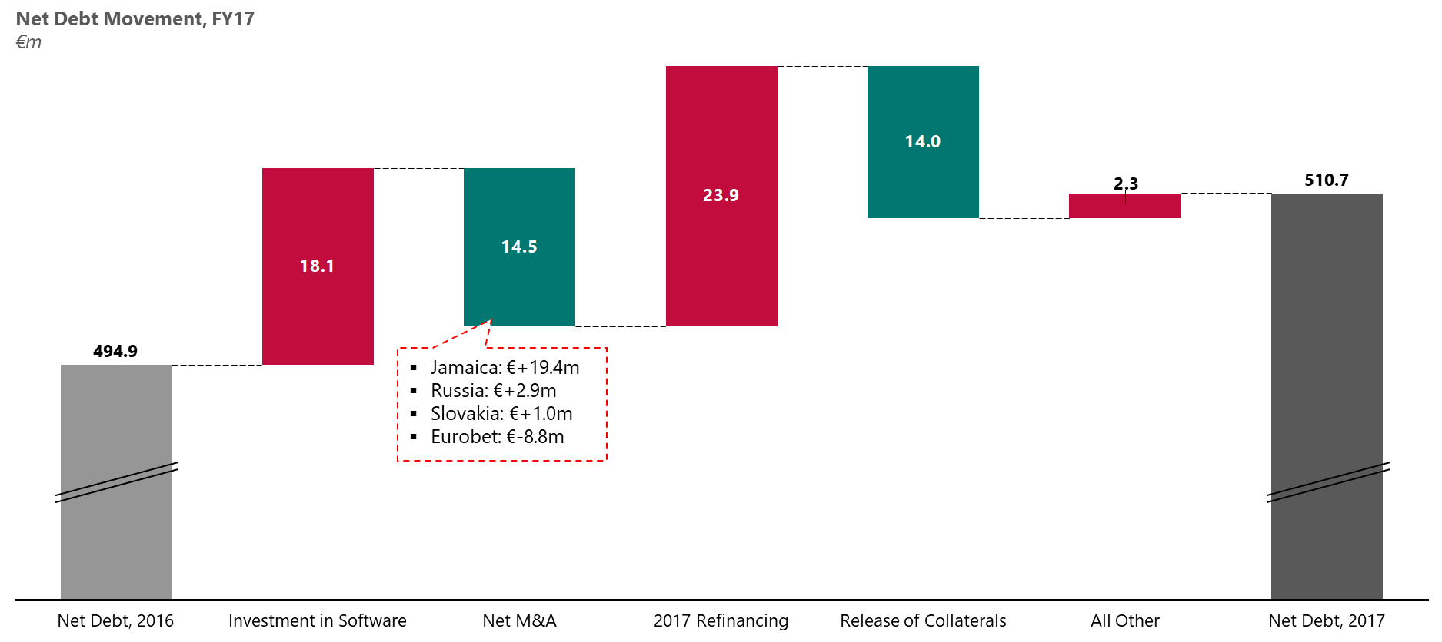

RECENT/ SIGNIFICANT COMPANY DEVELOPMENTS
- On January 17th, 2018, INTRALOT Group announced the completion of the acquisition of the 50% of the Cypriot company “KARENIA ENTERPRISES COMPANY LIMITED”, through its subsidiary INTRALOT Global Holdings BV. KARENIA ENTERPRISES holds a 30% stake in “ATHENS RESORT CASINO S.A.” which holds 51% of the Hellenic Casino Parnitha S.A.
- On February 1st, 2018, INTRALOT Group announced the signing of a new contract for INTRALOT Inc., a subsidiary of the INTRALOT Group in the United States, with CAMELOT Illinois LLC for the Illinois State Lottery through October 2027. INTRALOT will install technology solutions in approximately 7,500 retail locations. INTRALOT services are planned to transition in December 2018.
- On February 14th, 2018, INTRALOT Group announced the renewal of the current contract of INTRALOT Inc., a subsidiary of the INTRALOT Group in the United States, with the Wyoming Lottery for the five-year period from August 25, 2019, to August 25, 2024. This is the first of three five-year extension options in line with the initial contract terms.
- In mid-March 2018, INTRALOT Group proudly announced that it is one of the first companies in the gaming industry globally to be certified under the ISO 37001 standard for anti-bribery management systems. ISO 37001, Anti-bribery management systems, specifies a series of measures to help organizations prevent, detect and address bribery. These include adopting an anti-bribery policy, appointing a person to oversee anti-bribery compliance, training, risk assessments and due diligence on projects and business associates, implementing financial and commercial controls, and instituting reporting and investigation procedures.
- On April 25th, 2018, INTRALOT announced the appointment of Mr. Michael Kogeler, as Group Chief Operating Officer, effective May 2nd, 2018, following an extensive international search process. Mr. Kogeler will be responsible for the Group’s business orchestration of its operations around the world, the relationships with partners and customers as well as the trading operations.
- In early May 2018, INTRALOT Group announced that via its fully owned subsidiary, INTRALOT GLOBAL HOLDINGS BV, proceeded with the repurchase of Notes amounting to €5.0 million (€500M, 5.25% Senior Notes due 2024 ISIN XS1685702794). The Notes are traded on the Luxembourg Stock Exchange’s Euro MTF market.
- On May 14th, 2018, the US Supreme Court has ruled that PASPA (the Professional and Amateur Sports Protection Act), a 1992 federal law which prohibited states from legalizing sports betting, is unconstitutional.
APPENDIX
Performance per Business Segment
YTD Performance
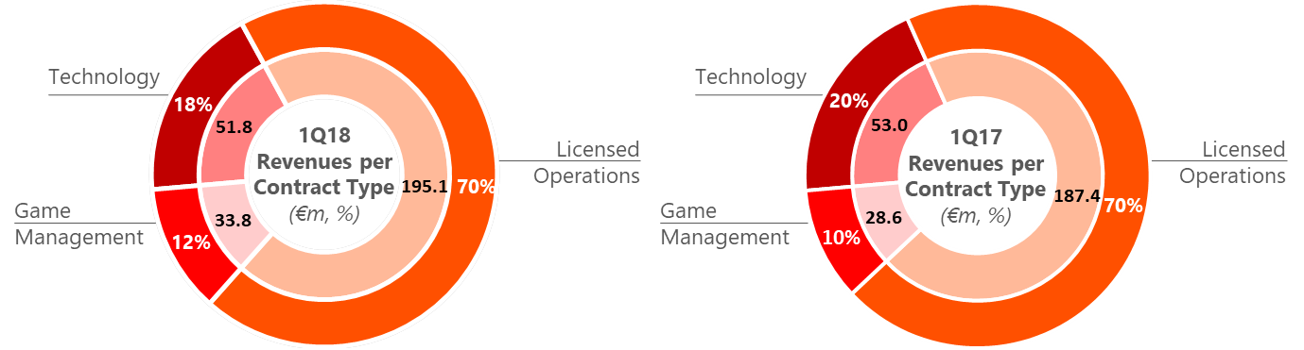
Performance per Geography
Revenue Breakdown
(in € million) | 1Q18 | 1Q17 | %  Change
Europe | 164.1 | 154.9 | 5.9%
Americas | 50.3 | 54.2 | -7.2%
Other | 78.8 | 72.4 | 8.8%
Eliminations | -12.5 | -12.5 | -
Total Consolidated Sales | 280.7 | 269.0 | 4.3%

Gross Profit Breakdown
(in € million) | 1Q18 | 1Q17 | %  Change
Europe | 19.1 | 16.9 | 13.0%
Americas | 5.6 | 6.8 | -17.6%
Other | 36.8 | 31.2 | 17.9%
Eliminations | -0.7 | -0.1 | -
Total Consolidated Gross Profit | 60.8 | 54.8 | 10.9%

Gross Margin Breakdown
 | 1Q18 | 1Q17 | %  Change
Europe | 11.6% | 10.9% | +0.7pps
Americas | 11.1% | 12.5% | -1.4pps
Other | 46.7% | 43.0% | +3.7pps
Total Consolidated Gross Margin | 21.7% | 20.4% | +1.3pps

INTRALOT Parent Company results
- Revenues for the period increased by 2.8% to €14.5m. The sales increase is primarily driven by the higher equipment sales related to our facilities management contract in Peru in 1Q18 vs. 1Q17.
- EBITDA decreased to €0.1m from €0.9m in 1Q17. The EBITDA variance is mainly the result of the negative OPEX variance y-o-y due to a doubtful debt provision for intragroup balances (€-1.3m) recorded in the 1Q18.
- Earnings after Taxes (EAT) at €0.0m from €4.8m in 1Q17.
- LTM EBITDA figure remained relatively stable, excluding the impact of the intragroup doubtful debt provision.

(in € million) | 1Q18 | 1Q17 | %  Change | LTM
Revenues | 14.5 | 14.1 | 2.8% | 67.2
Gross Profit | 4.8 | 5.3 | -9.4% | 27.6
Other Operating Income | 0.1 | 0.0 | - | 2.1
OPEX | -8.3 | -7.5 | +10.7% | 35.5
EBITDA | 0.1 | 0.9 | -89% | 8.0
EAT | 0.0 | 4.8 | - | -16.3
CAPEX (paid) | -4.7 | -3.2 | +46.9% | -17.0

CONFERENCE CALL INVITATION – Q1 2018 FINANCIAL RESULTS
Antonios Kerastaris, Group CEO, Georgios Koliastasis, Group CFO, Nikolaos Pavlakis, Group Tax & Accounting Director, Andreas Chrysos, Group Budgeting, Controlling & Finance Director and Michail Tsagalakis, Capital Markets Director, will address INTRALOT’s analysts and institutional investors to present the Company’s First Quarter 2018 results, as well as to discuss the latest developments at the Company.
The financial results will be released on the ATHEX website (www.helex.gr), and will be posted on the company’s website (www.intralot.com) on Thursday 31st May 2018.

AGENDA: Brief Presentation - Question and Answer Session
CONFERENCE CALL DETAILS
Date: Friday, 1st June 2018
Time: Greek time 17:00 - UK time 15:00 - CET 16:00 - USA time 10:00 (East Coast Line)
Conference Phone GR | + 30 211 180 2000
Conference Phone GR | + 30 210 94 60 800
Conference Phone GB | + 44 (0) 203 059 5872
Conference Phone GB | + 44 (0) 800 368 1063
Conference Phone US | + 1 516 447 5632
We recommend that you call any of the above numbers 5 to 10 minutes before
the conference call is scheduled to start.

LIVE WEBCAST DETAILS
The conference call will be available via webcast in real time over the Internet and you may join by linking at the internet site:
https://services.choruscall.eu/links/intralot18Q1.html
DIGITAL PLAYBACK

There will be a digital playback on the 1st June 2018 at 19:00 (GR Time).
This Service will be available until the end of the business day 12th June 2018.

Please dial the following numbers and the PIN CODE: 059 # from a touch-tone telephone

Digital Playback UK: + 44 (0) 203 059 5874
Digital Playback US: + 1 631 257 0626
Digital Playback GR: + 30 210 94 60 929
In case you need further information, please contact Intralot, Mr. Michail Tsagalakis, at the telephone number: +30 213 0397000 or Chorus Call Hellas S.A., our Teleconferencing Services Provider, Tel. +30 210 9427300.

SUMMARY OF FINANCIAL STATEMENTS
Group Statement of Comprehensive Income
(in € million) | 1Q18 | 1Q17 | % Change | LTM
Revenues | 280.7 | 269.0 | 4.3% | 1,115.9
Gross Profit | 60.8 | 54.8 | 10.9% | 247.9
Other Operating Income | 3.5 | 4.2 | -16.7% | 16.5
OPEX | -37.4 | -33.9 | 10.3% | -154.0
EBITDA | 42.6 | 41.8 | 1.9% | 172.3
Margin | 15.2% | 15.5% | -0.3pps | 15.4%
EBIT | 26.9 | 25.1 | 7.2% | 110.4
Interest expense (net) | -11.1 | -11.2 | -0.9% | -62.8
Exchange differences | -2.7 | 0.8 | - | -9.4
Other | 0.1 | -0.8 | - | -28.6
EBT | 13.2 | 13.9 | -5.0% | 9.6
NIATMI | -6.0 | -5.4 | -11.1% | -54.0
NIATMI continuing | -6.0 | -6.1 | 1.6% | -58.5
NIATMI discontinuing | 0.0 | 0.7 | - | 4.5
Group Statement of Financial Position
(in € million) | 1Q18 | FY17
Tangible Assets | 98.2 | 102.8
Intangible Assets | 321.7 | 324.5
Other Non-Current Assets | 183.2 | 178.6
Inventories | 36.8 | 31.5
Trade receivables | 72.5 | 84.2
Other Current Assets | 285.4 | 300.3
Total Assets | 997.8 | 1,021.9
Share Capital | 47.7 | 47.7
Other Equity Elements | -5.7 | 10.1
Non-Controlling Interests | 18.1 | 32.0
Total Shareholders’ Equity | 60.1 | 89.8
Long-term Debt | 744.8 | 729.4
Provisions/ Other Long term Liabilities | 30.6 | 29.6
Short-term Debt | 6.8 | 19.3
Other Short-term Liabilities | 155.5 | 153.8
Total Liabilities | 937.7 | 932.1
Total Equity and Liabilities | 997.8 | 1,021.9

Group Statement of Cash Flows
(in € million) | 1Q18 | 1Q17
EBT from continuing operations | 13.2 | 13.9
EBT from discontinuing operations | 0.0 | 4.0
Plus/less Adjustments | 29.7 | 28.8
Decrease/(increase) of Inventories | -4.4 | -0.2
Decrease/(increase) of Receivable Accounts | 6.8 | 1.7
(Decrease)/increase of Payable Accounts | -4.2 | -2.4
Income Tax Paid | -5.2 | -6.6
Net Cash from Operating Activities | 35.9 | 39.2
Net CAPEX | -14.2 | -24.6
(Purchases) / Sales of subsidiaries & other investments | -6.7 | -3.1
Interest received | 1.6 | 1.4
Net Cash from Investing Activities | -19.3 | -26.3
Cash inflows from loans | 26.3 | 31.5
Repayment of loans | -13.1 | -21.9
Repayment of Leasing Obligations | -0.6 | -0.5
Interest and similar charges paid | -23.4 | -13.0
Dividends paid | -15.5 | -10.8
Net Cash from Financing Activities | -26.3 | -14.7
Net increase / (decrease) in cash for the period | -9.7 | -1.8
Exchange differences | -5.0 | -2.1
Cash at the beginning of the period | 238.0 | 164.4
Cash at the end of the period from total operations | 223.3 | 160.5

About INTRALOT

INTRALOT, a public listed company established in 1992, is a leading gaming solutions supplier and operator active in 51 regulated jurisdictions around the globe. With €1.1 billion turnover and a global workforce of approximately 5,100 employees (3,100 of which in subsidiaries and 2,000 in associates) in 2017, INTRALOT is an innovation – driven corporation focusing its product development on the customer experience. The company is uniquely positioned to offer to lottery and gaming organizations across geographies market-tested solutions and retail operational expertise. Through the use of a dynamic and omni-channel approach, INTRALOT offers an integrated portfolio of best-in-class gaming systems and product solutions & services addressing all gaming verticals (Lottery, Betting, Interactive, VLT). Players can enjoy a seamless and personalized experience through exciting games and premium content across multiple delivery channels, both retail and interactive. INTRALOT has been awarded with the prestigious WLA Responsible Gaming Framework Certification by the World Lottery Association (WLA) for its global lottery operations.

For more info:
-Mr. Chris Sfatos, Group Director Corporate Affairs, email: sfatos@intralot.com or
-Investor Relations Dept. email: ir@intralot.com
Phone: +30-210 6156000, Fax: +30-210 6106800, www.intralot.com

Calculated as Proportionate EBITDA of fully consolidated entities including EBITDA from equity investments in Italy, Peru, Greece, and Taiwan
Licensed Operations Revenue include also a small portion of non-Payout related revenue, i.e. value added services, which totaled €1,2 million and €1,5 million for 1Q18 and 1Q17 respectively
Analysis in the EBITDA section excludes Depreciation & Amortization
Calculated as EBITDA – Maintenance CAPEX – Cash Taxes – Net Cash Finance Charges (excluding refinancing charges) – Net Dividends Paid; all finance metrics exclude the impact of discontinued operations

